# IT 140 Design Document Template

## Instructions

Fill out the sections below. Be sure to remove the bracketed text before submitting your Design Document.

Stephen Johnson

## Storyboard (Description and Map)

[Include a paragraph description of your theme, storyline, rooms, items, and villain here. Be sure to also complete the map below with *your* rooms and items. You may add more rooms and directions if you like. Use the **Insert** menu and select **Shapes** to add textboxes and arrows.] After having a fall that resulted in a coma, Stephen must venture to many rooms and find items to help him fight the villain that keeps him away from his family: himself. Stephen has spent years trying to provide for his family through work and college, however his family felt neglected. Therefore, it is up to Stephen to realize what is truly important and break the pattern that he’s built over the years before awakening to his family.

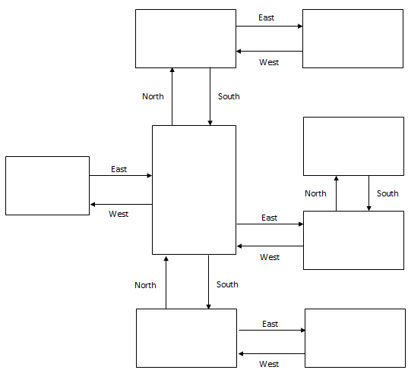

Raiden

Item: Crown

Stephen

Kristal

Item: Rib

Raeleigh

Item: Stringbean

Alexz

Item: Makeup

Kaidryn

Item: Hippo

Christmas

Item: Photo

Retribution

## Pseudocode or Flowchart for Code to “Move Between Rooms”

START current_room = “Stephen”

LOOP Beginning

INPUT direction

IF current_room is “Stephen”

IF direction is “North”

current_room = “Raeleigh”

ELSE IF direction is “South”

current_room = “Christmas”

ELSE IF direction is “West”

current_room = “Kristal”

ELSE IF direction is “East”

current_room = “Kaidryn”

ELSE

OUTPUT “Invalid Direction”

ELSE IF current_room = “Raeleigh”

IF direction is “South”

current_room = “Stephen”

ELSE IF direction is “East”

current_room = “Raiden”

ELSE

OUTPUT “Invalid Direction”

ELSE IF current_room = “Raiden”

IF direction is “West”

current_room =” Raeleigh”

ELSE

OUTPUT “Invalid Direction”

ELSE IF current_room = “Kristal”

IF direction is “East”

current_room = “Stephen”

ELSE

OUTPUT “Invalid Direction”

ELSE IF current_room = “Alexz”

IF direction is “South”

current_room = “Kaidryn”

ELSE

OUTPUT “Invalid Direction”

ELSE IF current_room = “Kaidryn”

IF direction is “North”

current_room = “Alexz”

ELSE IF direction is “West”

current_room = “Stephen”

ELSE

OUTPUT “Invalid Direction”

ELSE IF current_room = “Christmas”

IF direction is “North”

current_room = “Stephen”

ELSE IF direction is “East”

current_room = “Retribution”

ELSE

OUTPUT “Invalid Direction”

ELSE IF current_room = “Retribution”

IF direction is “West”

current_room = “Christmas”

ELSE

OUTPUT “Invalid Direction”

LOOP END

## Pseudocode or Flowchart for Code to “Get an Item”

Collect 6 items to win the game, or suffer in oblivion.

Move commands: go South, go North, go East, go West

Add to Inventory: get 'item name'

You are in Stephen’s Room

Inventory : []

……………………………………………………………………………….

Enter your move:

go North

You are in Raeleigh’s Room

Inventory : []

You see a Stringbean

……………………………………………….

Enter your move:

get the Stringbean

Stringbean obtained

You are in Raeleigh’s Room

Inventory : ['Stringbean']

…………………………………………….

Enter your move:

Go East

You are now in Raiden’s Room

Inventory : [‘Stringbean’]

You see a Crown

---------------------------

Enter your move: get the Crown

Crown obtained!

You are in Raiden’s Room

Inventory: [‘Stringbean’, ‘Crown’]

……………………………….

Enter your move:

Go West

You are in Raeleigh’s Room

Inventory: [‘Stringbean’, ‘Crown’]

…………………………………………

Enter your move:

Get Stringbean

Can’t get Stringbean

You are in Raeleigh’s Room

Inventory: [‘Stringbean’, ‘Crown’]

……………………………………………..

Enter your move:

Go South

You are now in Stephen’s Room

Inventory: [‘Stringbean’, ‘Crown’]

……………………………………………

Enter your move:

Go West

You are now in Kristal’s Room

Inventory: [‘Stringbean’, ‘Crown’]

You see the Rib

……………………………………………….

Enter your move:

Get the Rib

Rib obtained!

You are in Kristal’s Room

Inventory: [‘Stringbean’, ‘Crown’, ‘Rib’]

…………………………………………

Enter your move:

Go East

You are now in Stephen’s Room

Inventory: [‘Stringbean’, ‘Crown’, ‘Rib’]

…………………………………………..

Enter your move:

Go East

You are now in Kaidryn’s Room

Inventory: [‘Stringbean, ‘Crown’, ‘Rib’]

You see the Hippo

……………………………………………

Enter your move:

Get the Hippo

The Hippo obtained!

You are in Kaidryn’s Room

Inventory: [‘Stringbean’, ‘Crown’, ‘Rib’, ‘Hippo’]

………………………………………………

Enter your move:

Go North

You are now in Alexz’s Room

Inventory: [‘Stringbean’, ‘Crown’, ‘Rib’, ‘Hippo’]

You see the Makeup

…………………………………………………..

Enter your move:

Get the Makeup

The Makeup obtained!

You are now in Alexz’s Room

Inventory: [‘Stringbean’, ‘Crown’, ‘Rib’, ‘Hippo’, ‘Makeup’]

…………………………………………………

Enter your move:

Go South

You are in Kaidryn’s Room

Inventory: [‘Stringbean’, ‘Crown’, ‘Rib’, ‘Hippo’, ‘Makeup’]

…………………………………………………

Enter your move:

Go West

You are in Stephen’s Room

Inventory: [‘Stringbean’, ‘Crown’, ‘Rib’, ‘Hippo’, ‘Makeup’]

…………………………………………………..

Enter your move:

Go South

You are in the Christmas Room

Inventory: [‘Stringbean’, ‘Crown’, ‘Rib’, ‘Hippo’, ‘Makeup’]

You see the Christmas Photo

…………………………………………………..

Enter your move:

Get the Christmas Photo

The Christmas Photo obtained!

You are in the Christmas Room

Inventory: [‘Stringbean’, ‘Crown’, ‘Rib’, ‘Hippo’, ‘Makeup’, ‘Christmas Photo’]

………………………………………………………………

Enter your move:

Move

Invalid input!

You are in the Christmas Room

Inventory: [‘Stringbean’, ‘Crown’, ‘Rib’, ‘Hippo’, ‘Makeup’, ‘Christmas Photo’]

………………………………………………………….

Enter your move:

Go East

You are in the Retribution Room

Inventory: [‘Stringbean’, ‘Crown’, ‘Rib’, ‘Hippo’, ‘Makeup’, ‘Christmas Photo’]

You see the Villain in a mirror filled room!

OMG…Break them all…The End

GO HOME, mold a new you, Enjoy your life!

Thank you for playing. Family is a top priority.